CS4321 QUIZ 2 (Oct. 4)

NAME ( 5 points):

True or False (5 points).
  - 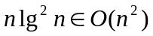 [ ]

  - 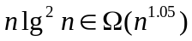 [ ]

  - 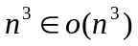 [ ]

  - The worst case cost of insertion sort is in 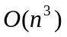 [ ]

  - The cost of selection sot is in 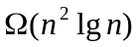 [ ]

  - With the assumption that the inputs are equally distributed, the average cost of insertion sort is 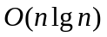 [ ]

  - A sequence of n INCREMENT operations on an initially zero k-bit counter takes total worst-case time 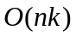 [ ]

  - A sequence of n INCREMENT operations on an initially zero k-bit counter takes total worst-case time 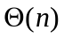 [ ]

  - The cost of the loop below is in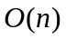 [ ]
for (i = 1; i <= n; i *= 2) { // n>=1
constant work;
}

  - The cost of the above loop is in   

